Tommy Ray Guess III

tray.guess@gmail.com – 303-731-9874 – linkedin.com/in/tommy-guess – trayguess.com

AUTOMATIC WASTE SORTING DEVICE

Rubi Araiza, Kat Edmond, Tommy Guess, Arthur Yuhang Li, Raquel Ruiz (2020)

The CODI (Categorically Operational Disposal Instrument) is a trash can capable of sorting waste into either a trash or recycling bin. This eliminates the need to sort manually and reduces the amount of nonrecyclables that contaminate recycling. A user throws trash into the top lid where it lands on a platform. There is a camera which automatically takes a picture of the waste and categorizes it using image detection algorithms on a Raspberry Pi. The platform then rotates, dropping the waste into the appropriate bin. The device requires no user input, and replacing the bins is made easy with a sliding platform. The prototype cost would be about $640, although the team is confident that this could be reduced with further design iterations.

I was involved in several phases of this project, including the electrical design and the platform rotation assembly. Due to the COVID-19 crisis, we were not able to physically build the CODI. However, we have a completely assembled CAD prototype as well as software capable of image detection in a proof-of-concept form. We designed each part with the manufacturing processes required in mind so that a prototype could be fabricated if needed in the future. This project was completed in three and a half weeks (18 class days) and culminated with a 30-minute virtual presentation given to the engineering and physics faculty.

PHOTOPLETHYSMOGRAPH

Noah Carpenter, Rubi Araiza, Kat Edmond, Tommy Guess (2019)

The photophlethysmograph was an optical heartbeat monitor designed in a group of four during our electronic instrumentation course. A light was shone through a finger into a photoresistor, producing a noisy signal containing the heartbeat. This signal was cleaned using a variety of circuitry, including a transimpedance amplifier, active op-amp filters and passive RC filters. This signal was converted to digital for a Raspberry Pi, where software detected beats. The bottom picture is an electrocardiogram output from the program, and the red dots represent heartbeats as automatically identified. From here, a beats-per-minute calculation was trivial. I personally acted as the project lead and was heavily involved in both circuitry design and software implementation.

SCISSOR LIFT

Tommy Guess, Anthony Holt, Collin Pfeifer Raquel Ruiz, Qingbao Wang (2018)

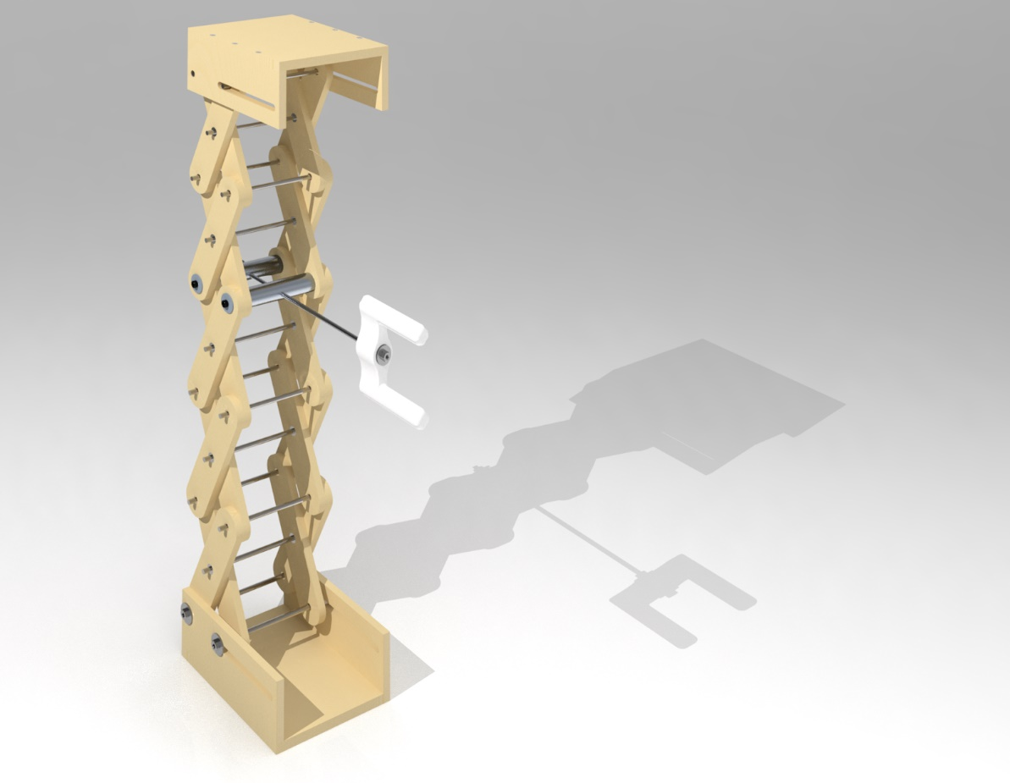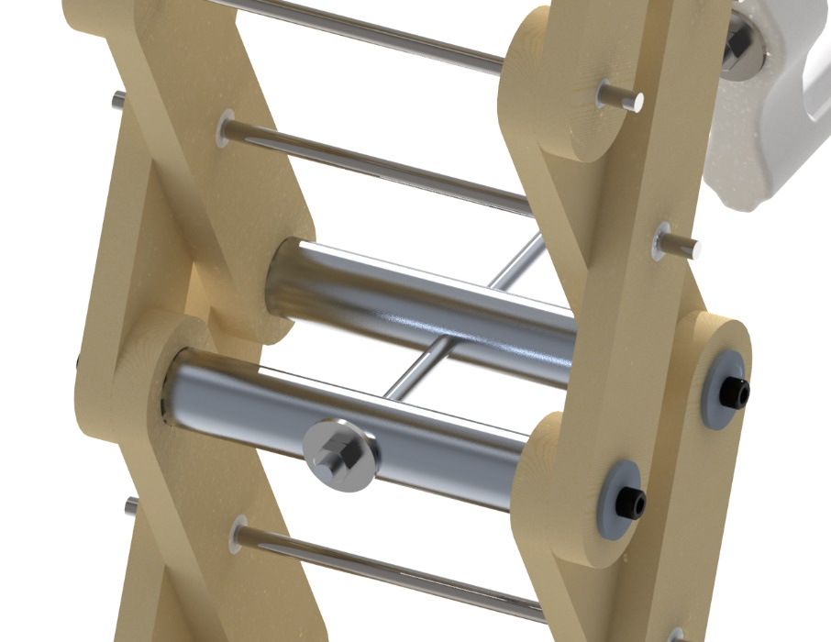

The scissor lift was designed to lift a load of 30 pounds by 2 feet. As the user rotates the handle, it draws metal bars closer or further apart, resulting in the lift raising or lowering. The device is designed to fail when lifting 50 pounds or more. One of the members will break, meaning that the user only needs to replace one part.

The process of designing and manufacturing the prototype took many steps. First, testing was done in order to determine the material properties of the particleboard which was the material of the force-bearing members, including yield stress, Young’s modulus, and ultimate tensile strength. Using this data, the team calculated the ideal member dimensions using numerical methods. Finite element analysis was then performed in PTC Creo Simulate, determining changes in stresses as the angle of the members changed. Finally, the prototype was fabricated using CNC machines, including a mill and a lathe. Unfortunately, the lift failed to lift 30 pounds. The reason for this was that the bearings generated an extra torque that had not been taken into consideration in the calculations. It was assumed that the bearings would be low enough friction to have negligible effect on the system, which was ultimately incorrect.

CONCERTO FOR TRUMPET

Composed by Tommy Guess. Premiered in 2020 by Tommy Guess, Trumpet

[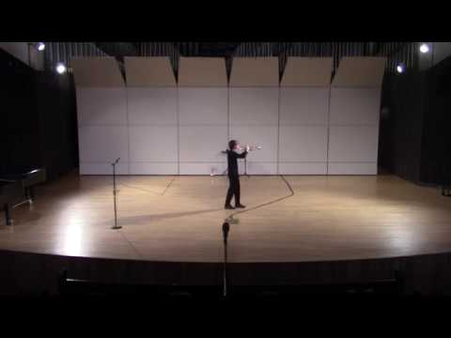](https://www.youtube.com/watch?v=0zYCOK1HI_w)

Concerto for Trumpet and Electroacoustic Instruments demonstrates some of my skills in audio design and production. This piece includes a live performer as well as a computer running Ableton Live. Several microphones connect to this computer, and the work features live audio effects (some examples are at 4:15, 5:40, and 14:58). Additionally, there is a click track for the performer using a wireless monitor.

This project was a technical challenge in terms of balance and blend. The performance room was a huge stone church with very little damping. I wrote the piece to take advantage of this setting, using the boominess as a strength. By turning backstage, I was able to substantially change the timbre of the trumpet, creating a unique and ghostly feel. When I wanted to avoid these reverberations, I staged the work so that I would be close to the audience. The various mutes allowed for me to produce a much brighter sound and thus create clarity that might otherwise have been lost to the room.

The audio from the computer was also an exercise in signal processing. Every sound played through the speakers is a modification of audio originally from my trumpet playing. I spend hours recording in a makeshift studio and later modifying those files to create unique timbres without pure synthesis.